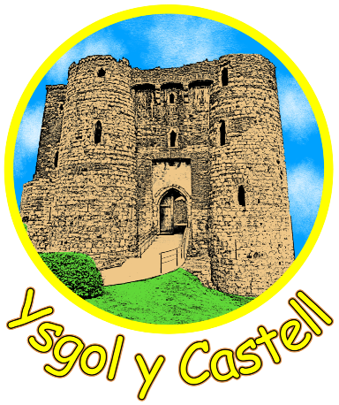

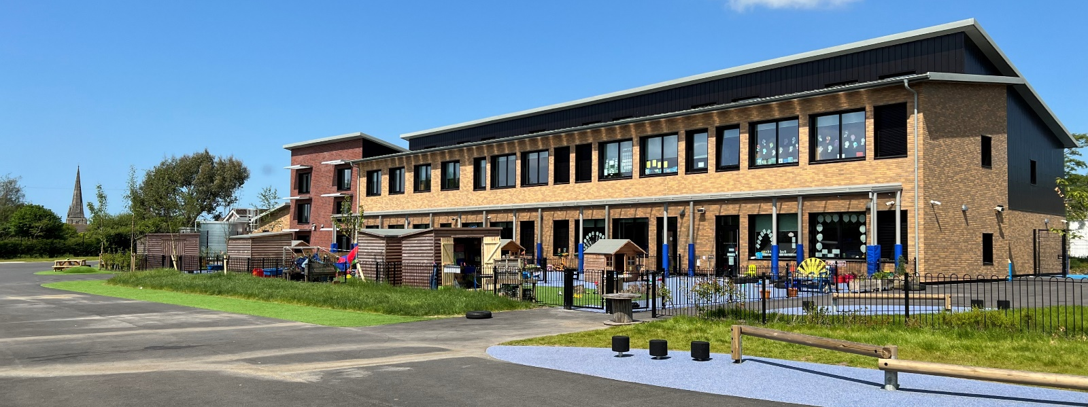
Care Share Believe Achieve
Ysgol y Castell
Governors Report to Parents
2024-25
Message from the Chair of Governors – Sharon Owen
Welcome to Ysgol y Castell Governing Body’s Annual Governors' Report to Parents. On behalf of the Governing Body, I would like to welcome back our current pupils, parents and carers, and staff to another exciting year ahead! May I also extend a warm welcome to any new pupils and their parents and carers who have just joined the school.

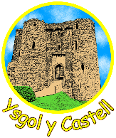
The purpose of the Annual Governor's Report to Parents is to inform you as to the current state of the school, including its staffing, estate, and future developments. The report details the work of the Governing Body over the last year in providing challenge, scrutiny, and support to the school as a 'critical friend'. Together with the school, and our community partners, we constantly strive towards the shared goal of providing the best educational experience and opportunities for our pupils, in a caring, nurturing, and supportive environment in line with our school motto, "Care Share Believe Achieve".

The work of the Governing Body includes regular meetings of the Full Governing Body every term, with responsibilities delegated to certain sub-committees to allow for greater scrutiny, challenge, and informed discussion to take place with reports back to the Full Governing body for information and any relevant votes to take place. Termly school visits are also required of each governor during which they will meet with class teachers to find out more information regarding a designated area of learning they have agreed to focus on. I'd like to thank my fellow members of our Governing Body for the dedication they have shown over the last year in the execution of their duties.

As a school, we endeavour to be constantly improving our school environment that encourages pupils to become resilient, independent, and confident individuals. The new school building and outdoor area will allow all these skills to be taught and developed while enhancing the ability for outdoor learning.

There are many areas where we as a school have prioritised development and will continue to do so over the next year.

Sharon Owen

School information for the coming year
Headteacher Delyth Goodfellow
Assistant Headteacher/ Acting Deputy Headteacher Ceris Knight
Office Manager Susan Thomas
Governors
Chair of Governors Sharon Owen
Vice Chair Darren Phillips
Clerk to Governors Susan Thomas
Address: Ysgol y Castell
Priory Street
Kidwelly
SA17 4TR
Tel: 01554 890762
E-mail : admin@ycastell.ysgolccc.cymru

Term Dates 2025-27
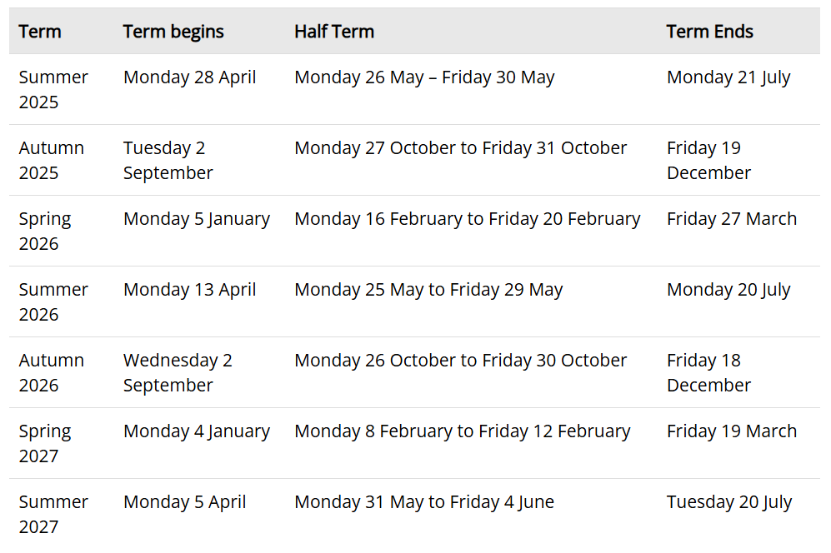
How do School Leaders and Governors promote school improvement?

At Ysgol y Castell, leaders have children’s safety, welfare and learning at the forefront of all decision-making. Each member of staff and each governor is a leader of at least one aspect of the school’s life, working as a strong team to improve and raise standards. Pupil voice, through the various school councils and parent consultation through regular meetings and surveys, mean that the whole school community is part of the consultation and decision making process. The Headteacher and her Senior Leadership Team work with all aspects of the school community to identify priorities, plan and action developments for these, and to closely monitor impact and outcomes. The Governing Body monitors school improvement priorities through regular visits to the school for meetings and learning walks; it also spends time on scrutiny of documentation and ensures that a rigorous appraisal procedure of the Headteacher and staff is adhered to. In all, the ‘Team’ ethos at Y Castell is key to the successful learning of all our children.

Staffing Structure 2024-25
Headteacher | Delyth Goodfellow
Assistant Headteacher | Ceris Knight | Year 4
Teachers
 | Maria Austin | P1 & 2 Lead, Reception & Nursery
 | Sioned Taylor | Year 1
 | Stephanie Jones | Year 2
 | Sian Reilly | Year 3
 | Bish Bowen | P3 Lead, Year 5/6
 | Tom Williams | Year 5
 | David Morgan | Year 6
 | Rachel Williams | ALNCo
LSA’s
Susan Smith, Anna Porter, Joanne King, Emma Norwood, Sarah Town, Rhian Baker,
Mel Woods, Karen House, Karen Jones, Maxine Duncan, Debbie Harding, Stacie Collins, Amy Reynolds
Administration
 | Sue Thomas, Lorraine Mears

SIP 2025-26
Priority 1 | To raise the standards of reading and comprehension across the school.
Priority 2 | To improve pupils’ speed accuracy and confidence in mental calculation strategies across all Progression Steps.
Priority 3 | To embed a whole-school Welsh ethos and secure the Siarter Iaith Aur Award by deepening pupil leadership, staff consistency and community engagement in Welsh.
Priority 4 | To strengthen the effectiveness of teacher feedback for extended writing to ensure that pupils make sustained progress.

Pupil Voice
We have various councils enabling pupils to have their voices heard, School Council, Eco Council, Healthy schools, Criw Cymraeg etc . Pupils continue to be involved in decisions around their learning. The school uses quite open topics giving maximum scope for pupils to open lines of enquiry! The teachers introduce the topics to give children some knowledge and then give them opportunity to make suggestions. Our younger children in Nursery and Reception are developing the confidence to make decisions about their play within clearly defined learning areas. Across the school councils are now meeting once a month to discuss, and make recommendations, on a range of areas. Some committees are able to get on and make the changes too!

Staff Development
The school continues to develop as a professional learning organisation. Staff develop through training and learning from one another. The approach of peer classroom observations for teaching staff was continued as a means to provide teachers with both the opportunity to observe good practice through the school, but to also improve their own teaching methods. We have continued to develop staff skills to deliver outdoor learning effectively. All the time we want staff to feel like working in Y Castell is a great experience and opportunity.

Community Visits and Visitors
The school makes use of visits and visitors to enhance the delivery of the curriculum. Nothing makes a topic come alive more than the first-hand experience and where practicable we endeavour to make these a part of the learning experience. Parents will no doubt have noticed from our social media feeds how often we have got children out and about in the local area of Kidwelly , visiting the Quay, the castle etc. This is never for a ‘jolly’. Although we know the children love it! Having first hand experiences enriches their learning and this has an impact on their overall wellbeing.

The Curriculum for Wales
The Four Core Purposes
As you know we introduced the Four Core Purposes Cats last year, the pupils have enjoyed designing and now enjoy receiving their certificates in well done assembly.
This is a recap of what our Four Cats represent.
We as a school wanted to have four mascots to represent ‘The Four Core Purposes’. It was decided that using pupil voice we would ask the pupils to design these mascots. As the black cat is a symbol of Kidwelly it was decided that we would use it as a base for our mascots.
All pupils from year 2 to year 6 were given the task on designing shields for the cats. During an assembly we spoke to the children, reminding them of TFCP and explained to them the important task they had of designing the shields. We also asked them to name the cats.
The pupils were very enthusiastic and we had some fantastic designs! We took elements from several designs and a local artist/illustrator put them together for us, these are the results –
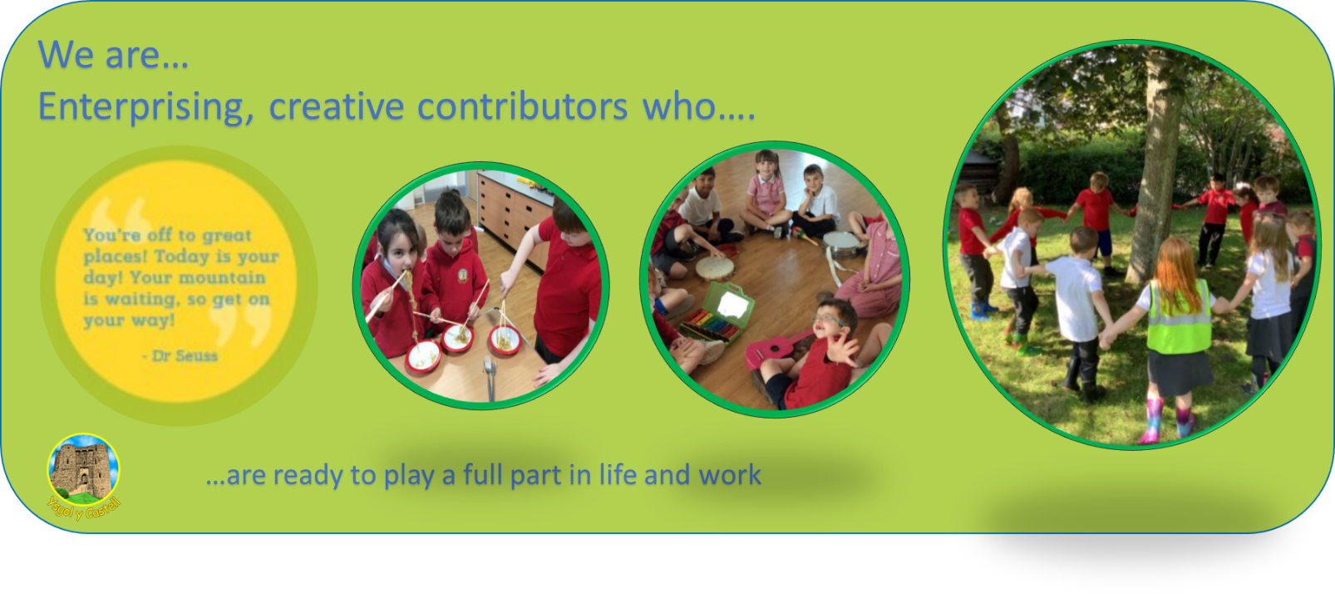
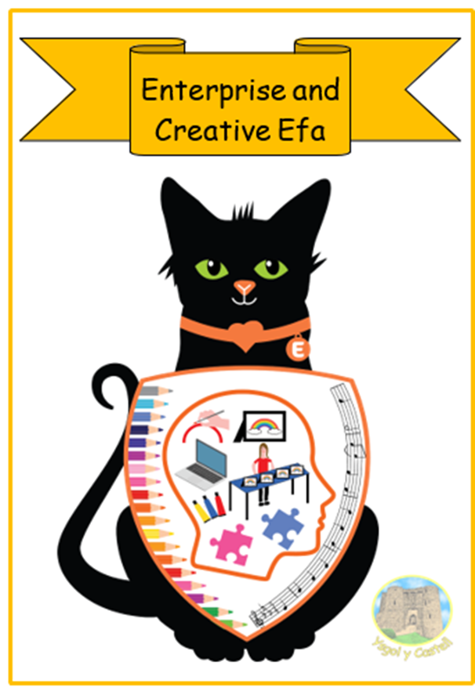
Enterprising, creative contributors who:
- connect and apply their knowledge and skills to create ideas and products;
- think creatively to reframe and solve problems;
- identify and grasp opportunities;
- take measured risks;
- lead and play different roles in teams effectively and responsibly;
- express ideas and emotions through different media;
- give of their energy and skills so that other people will benefit; and are ready to play a full part in life and work.
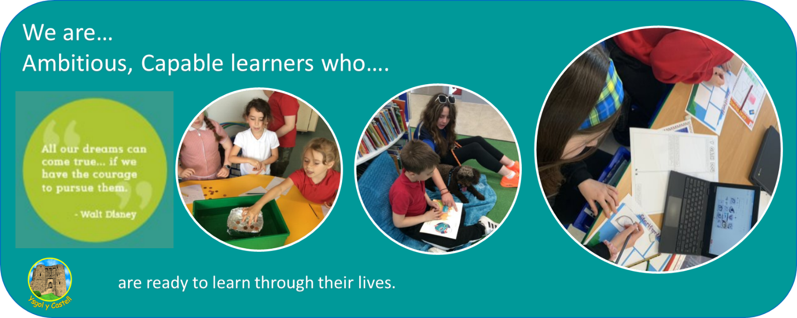
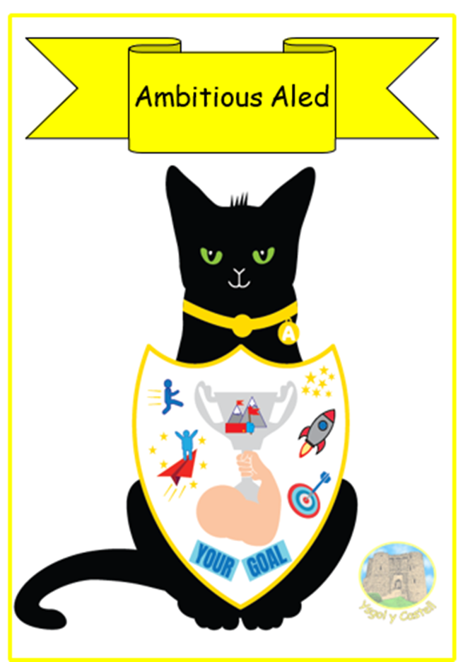

Ambitious, capable learners who:
- set themselves high standards and seek and enjoy challenge;
- are building up a body of knowledge and have the skills to connect and apply that knowledge in different contexts;
- are questioning and enjoy solving problems;
- can communicate effectively in different forms and settings, using both Welsh and English;
- can explain the ideas and concepts they are learning about;
- can use number effectively in different contexts;
- understand how to interpret data and apply mathematical concepts;
- use digital technologies creatively to communicate, find and analyse information;
- undertake research and evaluate critically what they find and are
ready to learn throughout their lives.

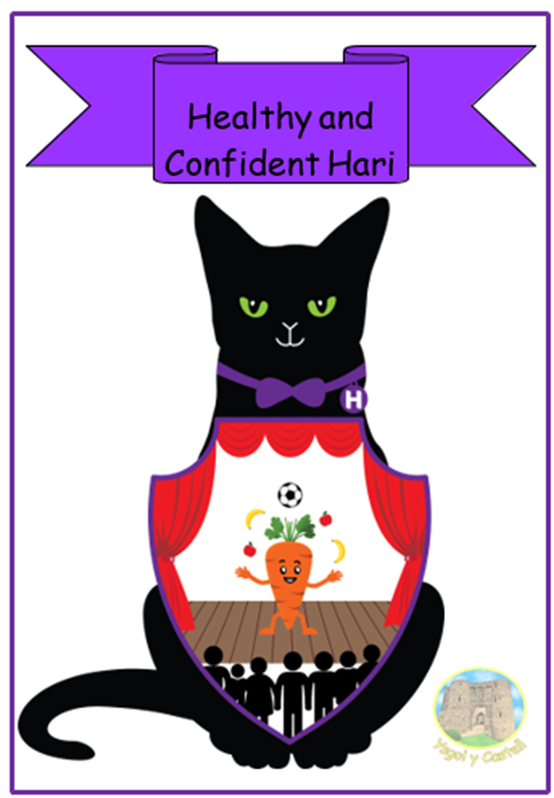
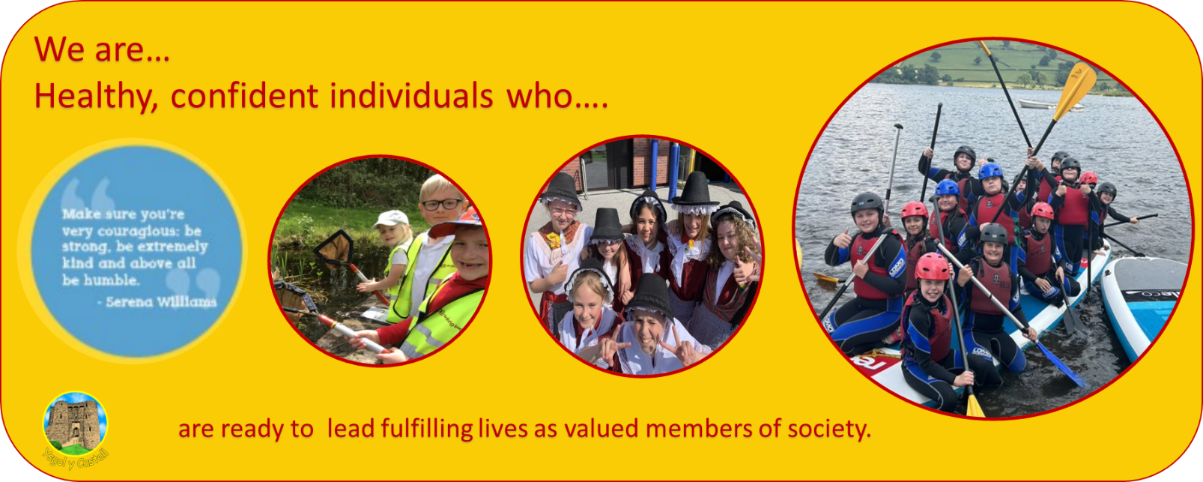
Healthy, confident individuals who:
- have secure values and are establishing their spiritual and ethical beliefs;
- are building their mental and emotional well-being by developing confidence, resilience and empathy;
- apply knowledge about the impact of diet and exercise on physical and mental health in their daily lives;
- know how to find the information and support to keep safe and well;
- take part in physical activity;
- take measured decisions about lifestyle and manage risk;
- have the confidence to participate in performance;
- form positive relationships based upon trust and mutual respect;
- have the skills and knowledge to manage everyday life as independently as they can;
- face and overcome challenge;
- and are ready to lead fulfilling lives as valued members of society.

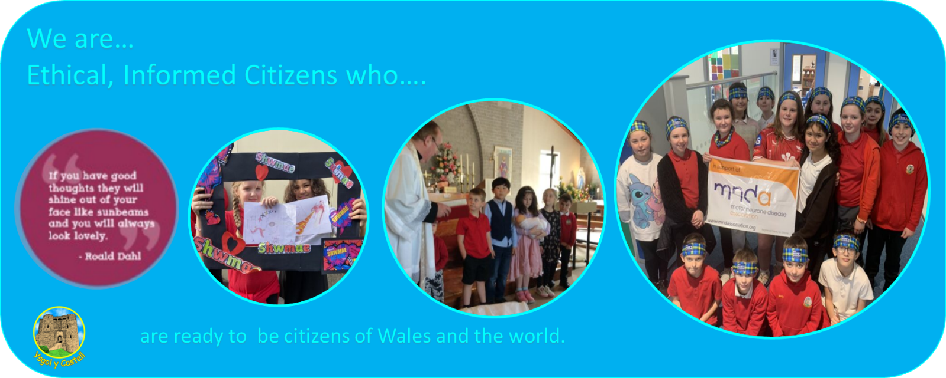
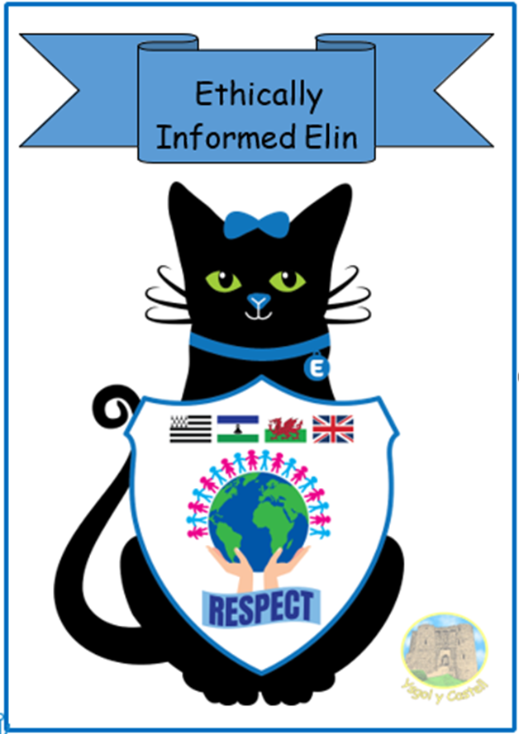
Ethical, informed citizens who:
- find, evaluate and use evidence in forming views;
- engage with contemporary issues based upon their knowledge and values;
- understand and exercise their human and democratic responsibilities and rights;
- understand and consider the impact of their actions when making choices and acting;
- are knowledgeable about their culture, community, society and the world, now and in the past;
- respect the needs and rights of others, as a member of a diverse society;
- show their commitment to the sustainability of the planet; and are ready to be citizens of Wales and the World.

