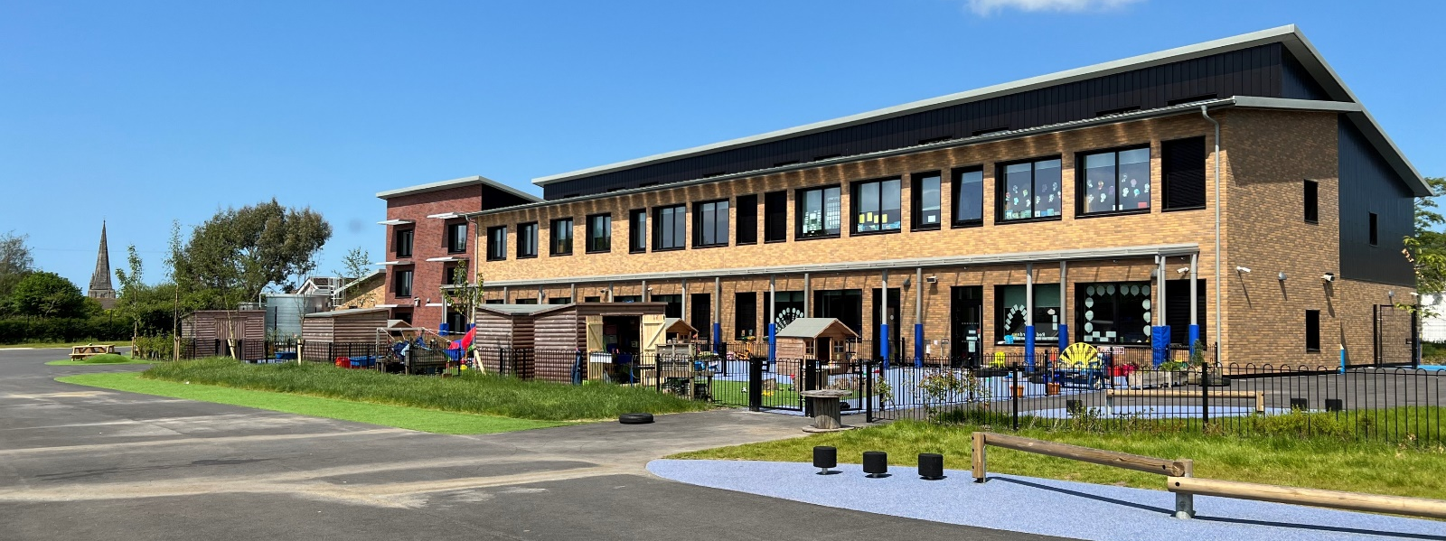
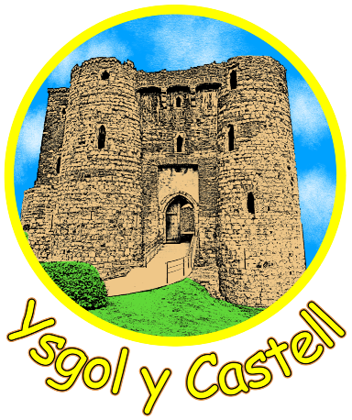
Ysgol y Castell
Governors Report to Parents
2022-23
Care Share Believe Achieve

Message from the Chair of Governors – Vanessa Hooper
Welcome to Ysgol y Castell Governing Body’s Annual Governors' Report to Parents. On behalf of the Governing Body, I would like to welcome back our current pupils, parents and carers, and staff to another exciting year ahead! May I also extend a warm welcome to any new pupils and their parents and carers who have just joined the school.


The purpose of the Annual Governor's Report to Parents is to inform you as to the current state of the school, including its staffing, estate, and future developments. The report details the work of the Governing Body over the last year in providing challenge, scrutiny, and support to the school as a 'critical friend'. Together with the school, and our community partners, we constantly strive towards the shared goal of providing the best educational experience and opportunities for our pupils, in a caring, nurturing, and supportive environment in line with our school motto, "Care Share Believe Achieve".

The work of the Governing Body includes regular meetings of the Full Governing Body every term, with responsibilities delegated to certain sub-committees to allow for greater scrutiny, challenge, and informed discussion to take place with reports back to the Full Governing body for information and any relevant votes to take place. Termly school visits are also required of each governor during which they will meet with class teachers to find out more information regarding a designated area of learning they have agreed to focus on. I'd like to thank my fellow members of our Governing Body for the dedication they have shown over the last year in the execution of their duties.

As a school, we endeavour to be constantly improving our school environment that encourages pupils to become resilient, independent, and confident individuals. The new school building and outdoor area will allow all these skills to be taught and developed while enhancing the ability for outdoor learning.

There are many areas where we as a school have prioritised development and will continue to do so over the next year.

Vanessa Hooper

School information for the coming year
Headteacher Delyth Goodfellow
Assistant Headteacher Ceris Knight
Assistant Headteacher Gwen Pearce
Office Manager Susan Thomas
Governors
Chair of Governors Vanessa Hooper
Vice Chair Darren Phillips
Clerk to Governors Susan Thomas
Address: Ysgol y Castell
Priory Street
Kidwelly
SA17 4TR
Tel: 01554 890762
E-mail : admin@ycastell.ysgolccc.cymru

Term Dates 2023-2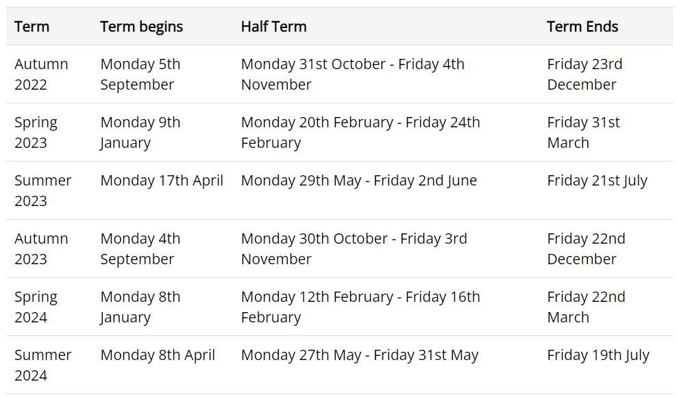
How do School Leaders and Governors promote school improvement?

At Ysgol y Castell, leaders have children’s safety, welfare and learning at the forefront of all decision-making. Each member of staff and each governor is a leader of at least one aspect of the school’s life, working as a strong team to improve and raise standards. Pupil voice, through the School and Eco Councils, and parent consultation through regular meetings and surveys, mean that the whole school community is part of the consultation and decision making process. The Headteacher and her Senior Leadership Team work with all aspects of the school community to identify priorities, plan and action developments for these, and to closely monitor impact and outcomes. The Governing Body monitors school improvement priorities through regular visits to the school for meetings and learning walks; it also spends time on scrutiny of documentation and ensures that a rigorous appraisal procedure of the Headteacher and staff is adhered to. In all, the ‘Team’ ethos at Y Castell is key to the successful learning of all our children.

Staffing Structure 2023- 24
Headteacher | Delyth Goodfellow
Assistant Headteachers | Gwen Pearce  Ceris Knight | Year 2  Year 4
Teachers
 | Kelly Feltwell (HLTA) | Nursery
 | Maria Austin | P1 Lead, Reception
 | Sioned Taylor | Year 1
 | Sian Reilly | P2 Lead, Year 3
 | Bish Bowen | P3 Lead, Year 4/5
 | Tom Williams | Year 5/6
 | David Morgan | Year 6
 | Rachel Williams | ALNCo
LSA’s
Susan Smith, Anna Porter, Joanne King, Emma Norwood, Sarah Town, Rhian Baker,
Mel Woods, Karen House, Karen Jones, Maxine Duncan, Debbie Harding, Stacie Collins, Amy Reynolds
Administration
 | Sue Thomas, Lorraine Mears

SIP 2023-24
Priority 1 | Whole school approach to emotional health and mental well-being
Priority 2 | To embed Talk 4 writing strategies with a focus on P3
Priority 3 | Develop the outdoor learning environment throughout the school
Priority 4 | To raise the standards of welsh across the school for both pupils and staff in line with the WESP timeline

Pupil Voice
We have various councils enabling pupils to have their voices heard, School Council, Eco Council, Healthy schools, Criw cymraeg etc . Pupils continue to be involved in decisions around their learning. The school uses quite open topics giving maximum scope for pupils to open lines of enquiry! The teachers introduce the topics to give children some knowledge and then give them opportunity to make suggestions. Our younger children in Nursery and Reception are developing the confidence to make decisions about their play within clearly defined learning areas. Across the school councils are now meeting once a month to discuss, and make recommendations, on a range of areas. Some committees are able to get on and make the changes too!

Staff Development
The school continues to develop as a professional learning organisation. Staff develop through training and learning from one another. The approach of peer classroom observations for teaching staff was continued as a means to provide teachers with both the opportunity to observe good practice through the school, but to also improve their own teaching methods. We have continued to develop staff skills to deliver outdoor learning effectively. All the time we want staff to feel like working in Y Castell is a great experience and opportunity.

Community Visits and Visitors
The school makes use of visits and visitors to enhance the delivery of the curriculum. Nothing makes a topic come alive more than the first-hand experience and where practicable we endeavour to make these a part of the learning experience. Parents will no doubt have noticed from our social media feeds how often we have got children out and about in the local area of Kidwelly , visiting the Quay, the castle etc. This is never for a ‘jolly’. Although we know the children love it! Having first hand experiences enriches their learning and this has an impact on their overall wellbeing.



